Agriculture Mechanics Show Results:

Abigail Esparza 2nd Place in Class 12’ Utility Trailer
Jaimyre Mitchell Reserve Grand Champion
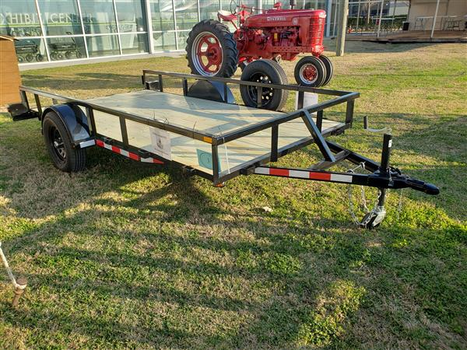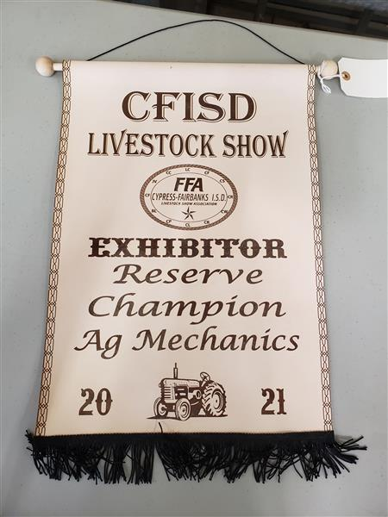

Anthony Gonzalez 3rd Place in Class 10’ Utility Trailer
Susan Ledezma
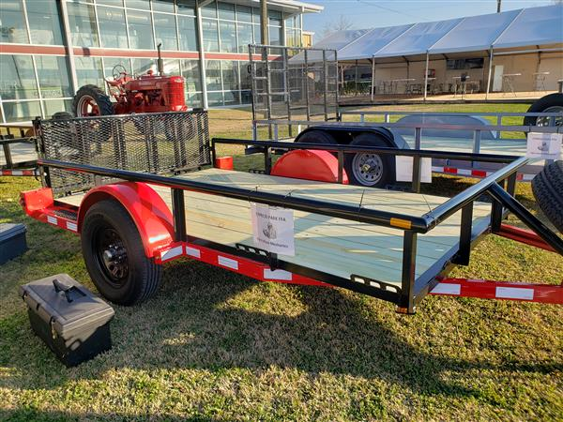

Karla Luz 4th Place in Class 16’ Utility Trailer
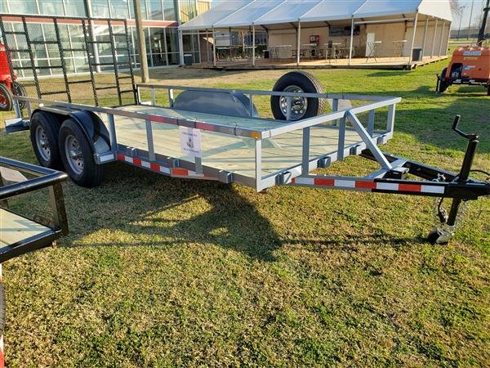

Breeding Heifer Show Results:
Madison Kreger 4th Place in Class
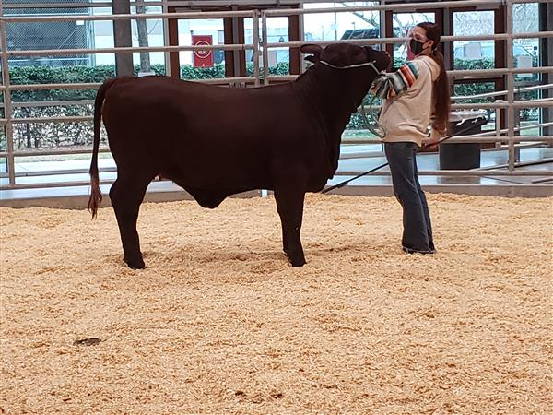

Market Rabbit Show Results:
Alexandra Ruiz – Placed in the top 20
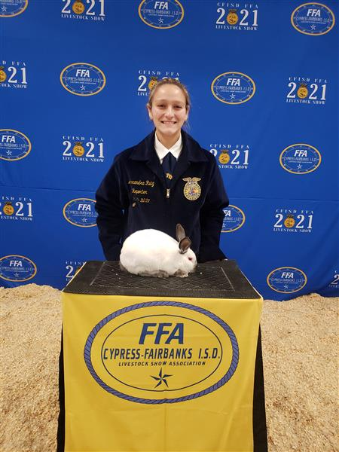

Market Goat Show Results:
Daryan Holland - 16th Place in Class
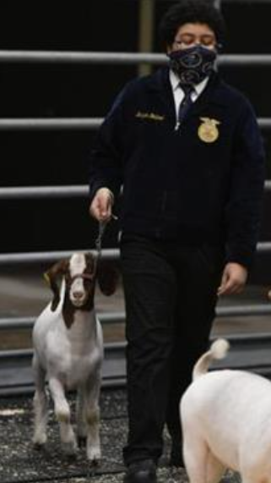
Market Lamb Show Results:
Alexandra Ruiz – 1st in class, 5th overall – Showmanship Call Back - $1,100.00 In Auction
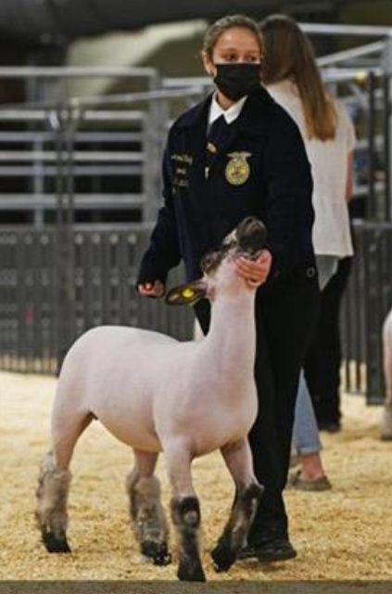

Kimberlye Kreger – 12th in Class – Called back for showmanship
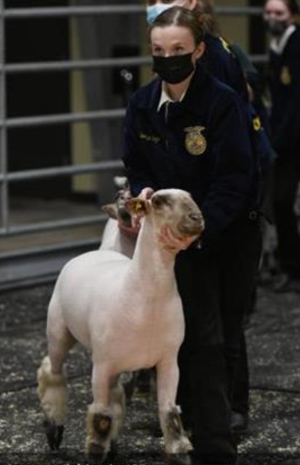

Ashton Woods – 11th in Class – Called back for showmanship
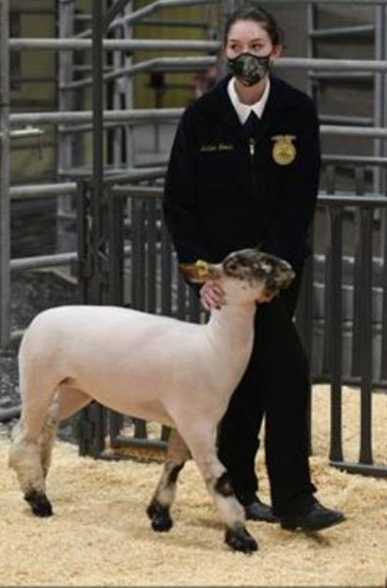

Market Hog Show Results:

Madison Alexander - Participant – Hog Show only recognizes the top 10 placings in class
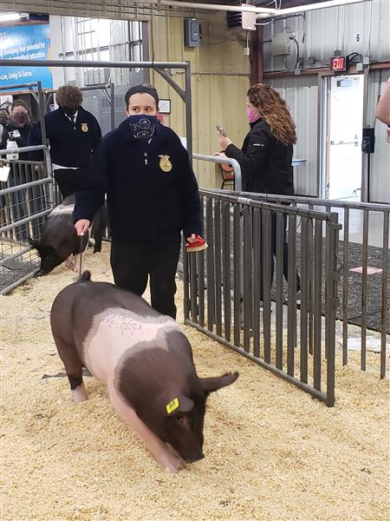

Xiomara Amaya – 6th in Class
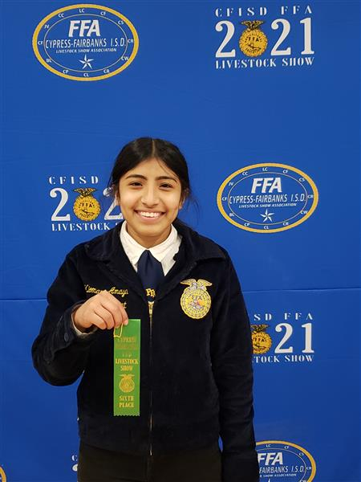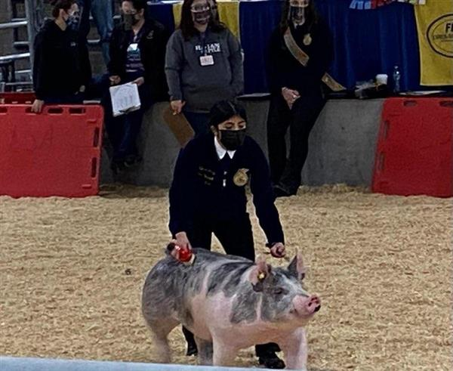

Hailey Gordon – 8th in Class
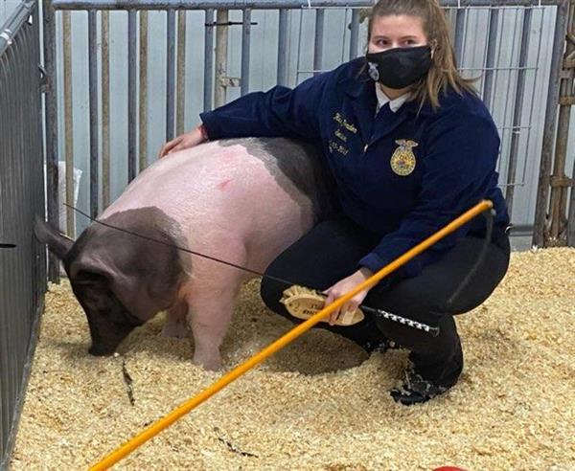

Noelle Berry - Participant – Hog Show only recognizes the top 10 placings in class
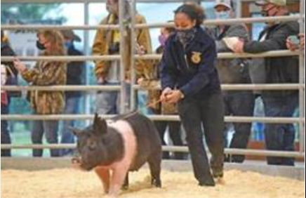

Matthew Duncan – Participant – Hog Show only recognizes the top 10 placings in class
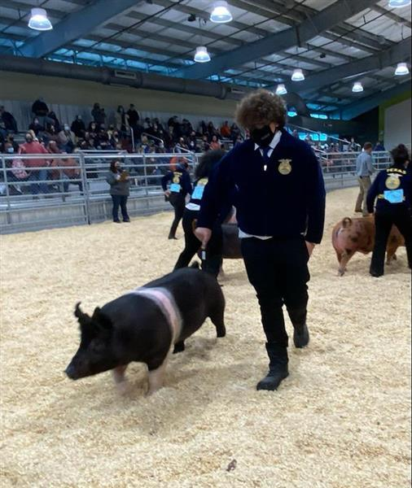

Isabella Gonzalez – Participant – Hog Show only recognizes the top 10 placings in class
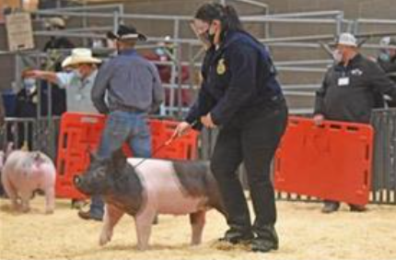

Lauren Kukla – Participant – Hog Show only recognizes the top 10 placings in class
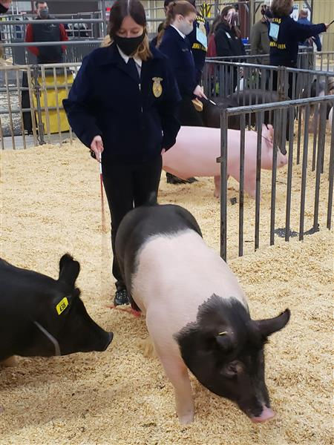

Market Steer Show Results:
Madison Kreger – 1st in class - 4th Overall – Showmanship Call Back - $4,200.00 In Auction
