We would like to recognize the following

FFA Members who served as Cypress Park FFA Chapter Officers during the 2016-2017 School Year.

**2016 – 2017**

President - Juan Carlos Sandoval

Vice President - Dayanne Guerra

Secretary - Evy Mendez

Treasurer - Chris Pelatari

Reporter - Steven Hernandez

Sentinel - Kendall Taylor

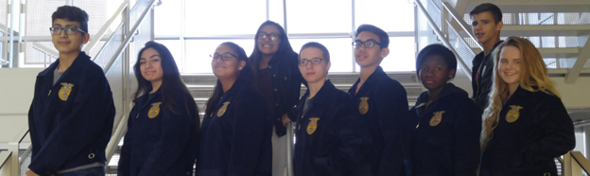

Kendall

Steven

Evy

Chris

Dayanne

Juan